**Python Tuples**

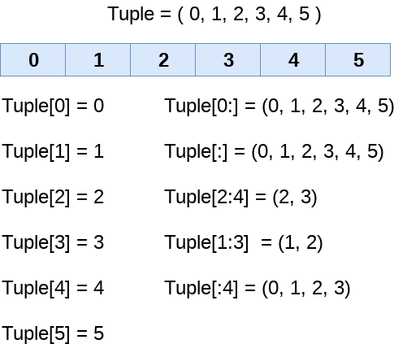

1.Create two tuples and do indexing and slicing.

tuple1=('a','b','c','d','e')

tuple2=(1,2,3,4,5)

print(tuple1[0])

print(tuple1[1])

print(tuple1[2])

print(tuple1[3])

print(tuple1[4])

print(tuple2[0])

print(tuple2[1])

print(tuple2[2])

print(tuple2[3])

print(tuple2[4])

print(tuple1[0:3])

print(tuple1[2:])

print(tuple1[:-3])

print(tuple2[1:4])

print(tuple2[-3:])

print(tuple1[:4])

**output:** a

b

c

d

e

1

2

3

4

5

('a', 'b', 'c')

('c', 'd', 'e')

('a', 'b')

(2, 3, 4)

(3, 4, 5)

('a', 'b', 'c', 'd')